
EVENT REPORT
One-Day Workshop on LaTeX
Organized by IEEE Student Branch — School of Engineering & Technology, Sanjivani University
1. Event Details
Event Name | One-Day Workshop on LaTeX
Organizing Body | IEEE Student Branch, School of Engineering & Technology, Sanjivani University
Target Audience | 2nd Year B.Tech Students
Date | 5th March 2026
Time | 12:30 PM onwards
Venue | 301 Lab, Sanjivani University
Session By | Dr. Chetan D. Bawankar
Event Type | Technical Workshop
2. About the Event
The IEEE Student Branch of the School of Engineering & Technology, Sanjivani University, successfully organized a One-Day Workshop on LaTeX on 5th March 2026. The workshop was specifically designed for 2nd Year B.Tech students to introduce them to the powerful document preparation system — LaTeX — which is widely used in academia, engineering, and scientific publishing.
The event aimed to equip participants with practical skills to typeset professional-quality technical and research documents at an early and formative stage of their B.Tech academic journey, laying a strong foundation for future research and publication work.
3. Objectives of the Workshop
- To introduce 2nd Year B.Tech students to LaTeX and its importance in technical and academic writing.
- To provide hands-on training on LaTeX document preparation, formatting, and structuring.
- To facilitate networking among students, researchers, and faculty.
- To offer project guidance to students undertaking research-based academic work.
- To build a culture of professional documentation among early-stage engineering students.
4. Workshop Highlights
# | Session / Activity | Description
1 | Introduction to LaTeX | Overview of LaTeX, its importance in academia, and a comparison with traditional word processors. Specially tailored for 2nd Year B.Tech students.
2 | Hands-on Session | Interactive practicals enabling participants to create documents, format equations, tables, and figures using LaTeX in real time.
3 | Networking | Platform for students, faculty, and researchers to interact, exchange ideas, and build professional connections.
4 | Project Guidance | Personalized guidance provided to students on using LaTeX for academic reports, mini-projects, and research submissions.
5. Resource Person
The workshop session was conducted by Dr. Chetan D. Bawankar, a distinguished academician and expert in technical documentation. Dr. Bawankar guided the 2nd Year B.Tech participants through the nuances of LaTeX with practical examples and live demonstrations, ensuring an engaging and highly productive learning experience for students at this stage of their engineering program.
6. Organizing Committee
Name | Designation | Role
Hon'ble Shri. Amit Kolhe | President, Sanjivani University | Patron
Dr. A.G. Thakur | Vice Chancellor, Sanjivani University | Patron
Dr. Kavitha Rani P. | Dean-SET, SU & Faculty Advisor - IEEE | Faculty Advisor
Dr. Devyani Jadhav | IEEE Student Branch Counsellor | Branch Counsellor
Dr. Tanay Ghosh | Asst. Prof., SU | Student Coordinator
7. Outcome & Conclusion
The One-Day Workshop on LaTeX was a resounding success among the 2nd Year B.Tech students of Sanjivani University. Participants gained practical exposure to LaTeX-based document preparation, enabling them to produce high-quality academic reports, presentations, and research papers. The hands-on sessions and interactive project guidance ensured meaningful learning outcomes at this crucial stage of their engineering studies.
The event reinforced the IEEE Student Branch's commitment to fostering technical excellence and professional development. The workshop received enthusiastic participation and appreciation from attendees, and the IEEE Student Branch looks forward to organizing more such knowledge-enriching events in the future.
8. Event Photographs
Photographs from the workshop are included below for documentation purposes.

______________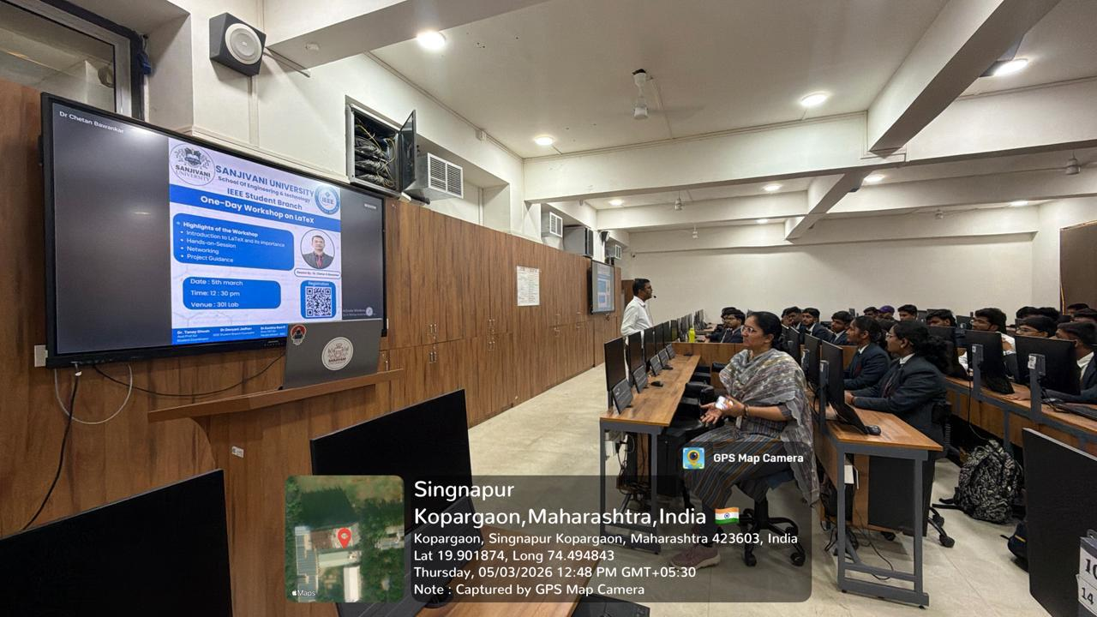 | 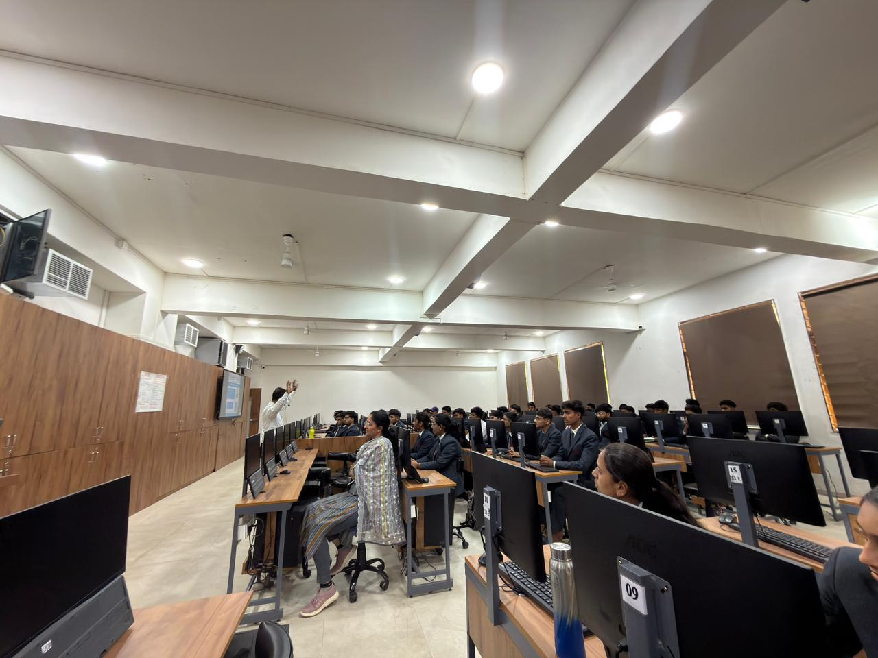

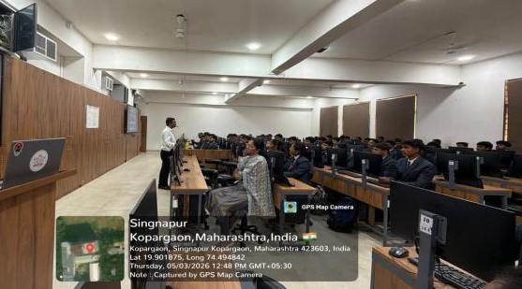 | 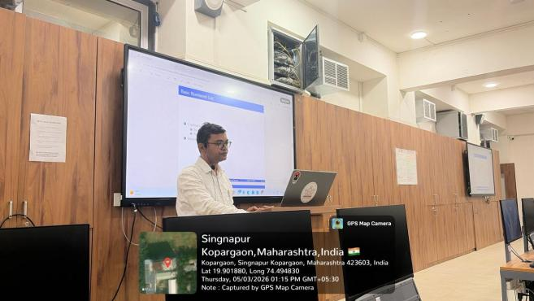

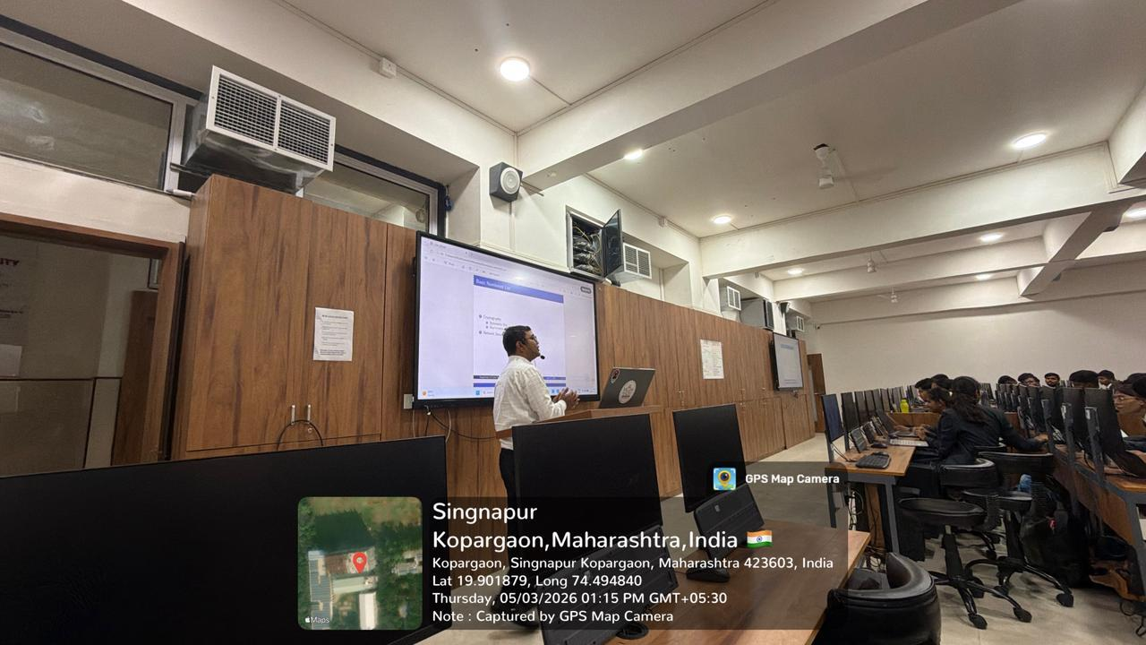

Student Coordinator | Branch Counsellor / Faculty Advisor | Dean, SET

