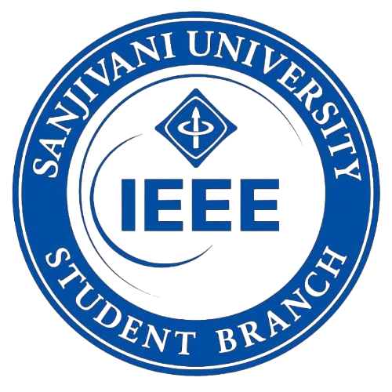
EVENT REPORT
Basic to Advanced
GitHub Session
Organized by IEEE Student Branch, Sanjivani University
1. Event Details
Event Name | Basic to Advanced GitHub Session
Organizing Body | IEEE Student Branch, School of Engineering & Technology, Sanjivani University
Target Audience | Integrated B.Tech Students (Exclusive Session)
Date | 5th March 2026
Time | 10:00 AM – 12:00 PM
Venue | Lab 404, Sanjivani University
Session Conducted By | Ms. Sailee Abhale, Vice Chair — IEEE Student Branch, Sanjivani University (3rd Year B.Tech Student)
Mode | Hands-on / Practical (Laptop Mandatory)
Event Type | Technical Workshop / Skill Development Session
2. About the Event
The IEEE Student Branch of the School of Engineering & Technology, Sanjivani University, successfully organized a comprehensive GitHub Session titled 'Basic to Advanced' on 5th March 2026. The session was conducted exclusively for Integrated B.Tech students and was designed to bridge the gap between theoretical knowledge and practical industry-standard version control skills.
A notable highlight of this event was that the session was entirely conducted by Ms. Sailee Abhale, Vice Chair of the IEEE Student Branch and a 3rd Year B.Tech student of Sanjivani University. Ms. Abhale demonstrated exceptional technical expertise and leadership by designing and delivering the entire session — from basic Git concepts to advanced GitHub workflows — for her fellow students.
GitHub and Git are among the most essential tools in modern software development, collaborative coding, and open-source contribution. This session provided Integrated B.Tech students with structured, hands-on exposure to Git operations, while simultaneously offering Ms. Abhale a meaningful platform to sharpen her own teaching, communication, and technical skills.
3. Objectives of the Session
- To introduce Integrated B.Tech students to Git and GitHub from a beginner to advanced level.
- To provide 100% practical, hands-on learning experience with real Git operations.
- To teach core Git operations including branching, merging, pull requests, and conflict resolution.
- To equip students with version control skills essential for academic projects and industry internships.
- To promote collaborative software development practices among engineering students.
4. Session Highlights
# | Session / Activity | Description
1 | Hands-on Learning (Basic to Advanced) | Step-by-step practical sessions covering Git from initial setup and basic commands to advanced workflows like branching strategies and merge conflict resolution.
2 | Core Git Operations | In-depth coverage of essential Git commands: init, clone, add, commit, push, pull, branch, merge, rebase, and stash — applied through live exercises.
3 | GitHub Collaboration | Participants practiced collaborative development workflows including forking repositories, creating pull requests, reviewing code, and contributing to shared projects.
4 | 100% Practical Learning | The entire session was structured as a hands-on lab exercise. Participants were required to bring laptops and execute every command in real time during the session.
5. Session Conducted By
Name | Ms. Sailee Abhale
Position | Vice Chair, IEEE Student Branch, Sanjivani University
Program | B.Tech — Artificial Intelligence and Data Science
Year | 3rd Year
Department | Dept. of Artificial Intelligence & Data Science, SET

The session was conducted by Ms. Sailee Abhale, Vice Chair of the IEEE Student Branch, Sanjivani University, and a 3rd Year B.Tech student from the Department of Artificial Intelligence and Data Science. Her ability to design and deliver a structured technical session — covering Git and GitHub from basics to advanced level — demonstrates remarkable technical proficiency and leadership at an early stage of her academic career.
Conducting this session was not only a meaningful contribution to her peers but also a significant milestone in Ms. Abhale's own professional development. Preparing and presenting a fully practical, hands-on GitHub workshop helped her deepen her own understanding of Git workflows and version control best practices, sharpen her communication and mentoring abilities, and grow as a student leader within the IEEE community. The experience directly complemented her AI & Data Science curriculum, where collaborative coding and repository management are essential skills. This session is a proud example of the IEEE Student Branch's belief in student-led, peer-to-peer technical empowerment.
6. Key Requirements & Prerequisites
- Participants were required to bring their own laptops — Laptop Mandatory.
- Git and a GitHub account were required to be set up prior to the session.
- The session was exclusively open to Integrated B.Tech students of Sanjivani University.
- Participation was strictly limited to Integrated B.Tech students as per event guidelines.
7. Organizing Committee
Name | Designation | Role
Hon'ble Shri. Amit Kolhe | President, Sanjivani University | Patron
Dr. A.G. Thakur | Vice Chancellor, Sanjivani University | Patron
Dr. Kavitha Rani P. | Dean-SET, SU & Faculty Advisor - IEEE | Faculty Advisor
Dr. Devyani Jadhav | IEEE Student Branch Counsellor | Branch Counsellor
Dr. Tanay Ghosh | Asst. Prof., SU | Student Coordinator
Ms. Sailee Abhale | 3rd Year B.Tech, AI & DS Dept. | Vice Chair, IEEE SB & Session Conductor
8. Outcome & Conclusion
The Basic to Advanced GitHub Session was an exceptional success, drawing enthusiastic participation from Integrated B.Tech students of Sanjivani University. The fully practical format of the session ensured that every participant left with hands-on experience in Git version control and GitHub collaboration workflows.
A standout aspect of this event was that it was entirely conducted by Ms. Sailee Abhale, a 3rd Year B.Tech student and Vice Chair of the IEEE Student Branch. Her initiative, preparation, and delivery reflected strong leadership and technical depth. The experience of conducting the session also contributed significantly to her own skill enhancement — deepening her expertise in Git workflows and strengthening her abilities as a student mentor and technical communicator.
The IEEE Student Branch reaffirms its dedication to bridging the gap between academic learning and real-world technical skills, and looks forward to organizing more such impactful student-led events.
9. Event Photographs
Photographs from the session are included below for documentation purposes.

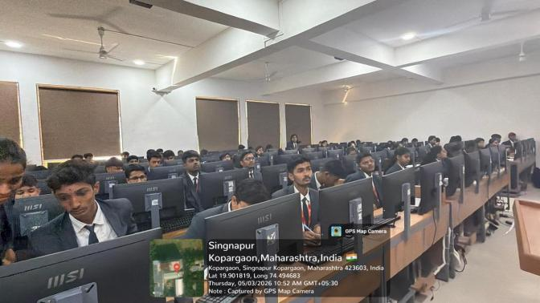  Caption: _______________________________ | 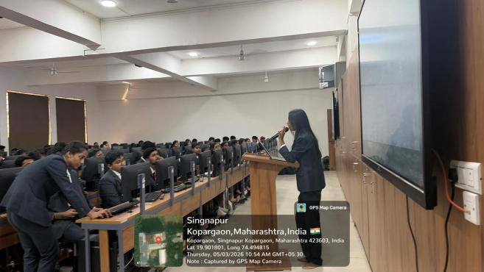  Caption: _______________________________

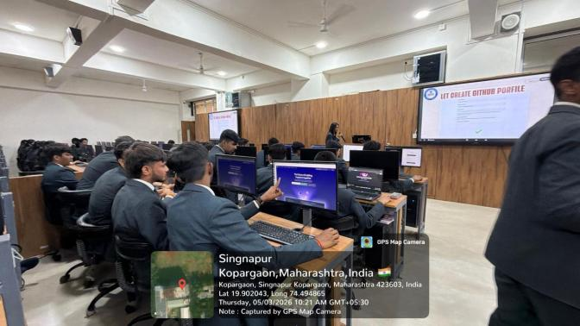  Caption: _______________________________ | 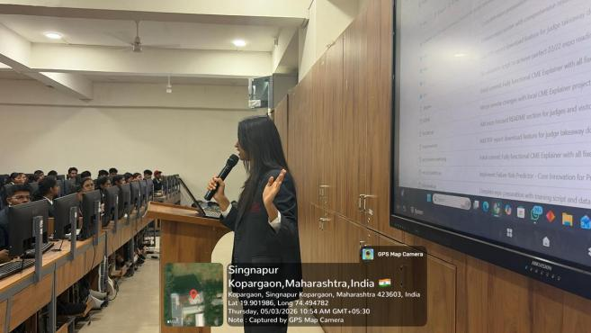  Caption: _______________________________

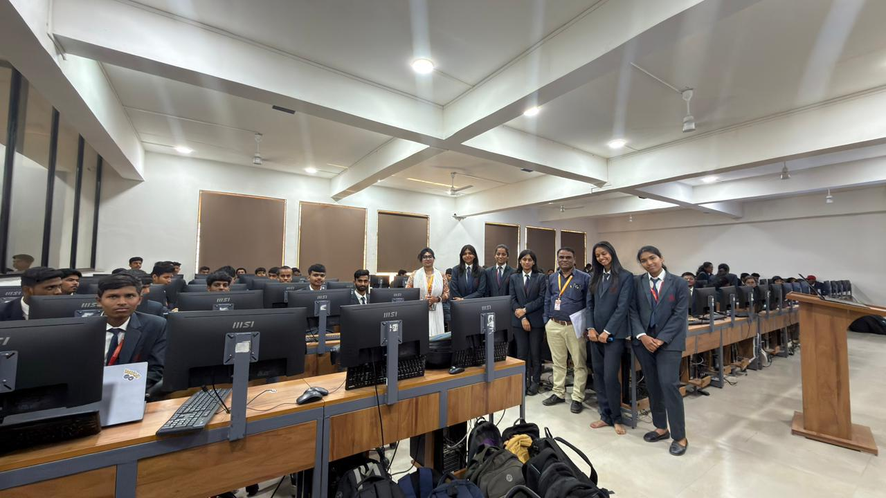
Caption: _______________________________

Student Coordinator | Branch Counsellor / Faculty Advisor | Dean, SET

